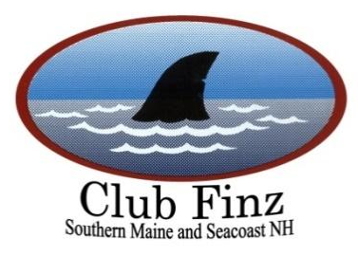

Club Finz Parrot Head Club

Membership Application

Club Finz is a non-profit organization whose purpose is to assist community and environmental concerns and to provide a variety of social activities for people with similar tastes and interests. Club Finz is not a Federal non-profit; it is a State non-profit and as such, club dues may not be considered charitable deductions for tax purposes.
As a member you will receive the following:
- Email invitations to all club sponsored social and volunteer events
- Automatic membership in the Parrot Heads in Paradise (PHIP)
Please include this application with your check and make checks payable to Club Finz and mail to:
Club Finz
PO BOX

Name: (1) ___________________________________________
Badge Name/Nickname: (1)____________________________
Email: (1)__________________________________________
Cell: (1)___________________________________________

(2)____________________________________________
(2)_____________________________________________
(2)_____________________________________________
(2)______________________________________________
Address: _____________________________________ City:_____________________ State: _____ Zip Code: ____________
Home Phone: ________________________
Would you like to be included in a text chain for "urgent" information - such as canceling a HH? Or a change in location? YES/NO

Fee Schedule (Per Year)
1 Single Adult $20.00

2 Adults residing in the same home $30.00

Note: a completed copy of this application must accompany your dues payment.

*With your consent, your email address will be added to the club directory, available only to Club Finz Board members, strictly for social purposes and will not be used for spam, business promotion or any purpose other than keeping in touch with other members outside of the club.

For more information, please visit us on the web at www.clubfinz.com

